**Vivian French**

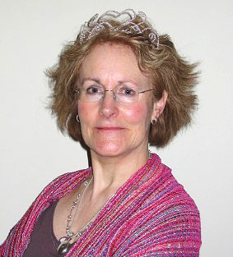

Vivian French was best known in school for being extremely skinny and for talking a lot.

At school, she developed an attachment to words and later became an actor, then a storyteller, and finally a writer of children's books.

She is the author of more than two hundred books.

Vivian lives in Edinburgh and has four grown-up daughters.