**Swapna Haddow**

Swapna Haddow, as a child, wanted to run the wrong way up a slide. At the age of seven and three-quarters, she archived this and then moved her aspirations on to being a writer.

She wrote her first book when she was eight and wishes she had kept it, rather than trading it for stickers and a marble.

Swapna studied medicine, but then decided that being a Doctor wasn’t for her.

She wrote and wrote and with lots of encouragement from her family, “Dave Pigeon” was published. It has been shortlisted for many book prizes.

Swapna lives in New Zealand with her husband, son and dog.

[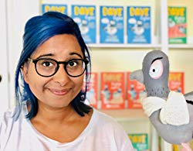](https://www.google.co.uk/url?sa=i&rct=j&q=&esrc=s&source=images&cd=&cad=rja&uact=8&ved=2ahUKEwj3o7XXyY7hAhVGrxoKHSEVB0AQjRx6BAgBEAU&url=https://www.amazon.co.uk/Swapna-Haddow/e/B01N0LAT8F&psig=AOvVaw1gYP1LnWNVcbCzH4kYJ4V0&ust=1553097619102896)